Atriis SSO Setup Guide (SAML 2.0)

Overview
This guide explains how to configure Single Sign-On (SSO) for Atriis using the SAML 2.0 protocol.
The setup requires coordination between your IT team and Atriis.

1. Before You Start
Please confirm:
- Whether your Identity Provider (IdP) will be configured by:
  - Your IT team
  - Atriis team (we can assist if needed)
- Whether you are using:
  - Azure AD
  - Another SAML provider

Important
Some configuration steps require a unique identifier (GUID).
- Your IT team can generate it, OR
- You can request it directly from the Atriis team, and we will provide all required values

2. SSO Setup (Non-Azure AD)

Step 1: Create and Configure Your Identity Provider (IdP)
Create a new SAML application using the following details:
- Audience (Entity ID):
https://www.gtp-marketplace.com/Saml2
- ACS (Assertion Consumer Service) URL:
https://www.gtp-marketplace.com/identity/<UNIQUE_ID>/Acs

Important
- <UNIQUE_ID> must be a GUID
- You can generate it using GUID Generator or a similar service.
- Make sure hyphens are NOT included
- Alternatively, you can request this value from Atriis, and we will provide the full configuration details

Step 2: Share Metadata and IdP with Atriis
Once configuration is complete, please provide:
- Metadata URL (preferred), OR
- Metadata file
- ACS (Assertion Consumer Service) URL:
https://www.gtp-marketplace.com/identity/<UNIQUE_ID>/Acs

3. SSO Setup (Azure AD)

Step 1: Create Your Identity Provider (IdP)
- Identifier (Entity ID):
https://www.gtp-marketplace.com/identity/
(Trailing slash is required)
- Reply URL (ACS):
https://www.gtp-marketplace.com/identity/<UNIQUE_ID>
- Sign-on URL:
https://www.gtp-marketplace.com/sso/newidp?provider=<UNIQUE_ID>&clientId=atriis_ui_production_sso&redirectUri=https://www.atriis.app/signin

Important:
- <UNIQUE_ID> must be a GUID
- You can generate it using GUID Generator or a similar service.
- Make sure hyphens are NOT included
- Alternatively, you can request this value from Atriis, and we will provide the full configuration details

Step 2: Configure the IdP Details in Azure:
Create a new enterprise application and configure the above details as follows:
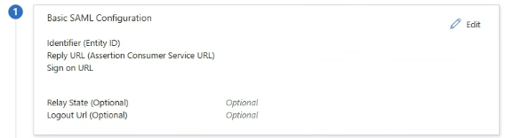

Step 3: Share IdP and Metadata Details:
- Please provide the Metadata URL only
- Metadata files are not supported for Azure AD
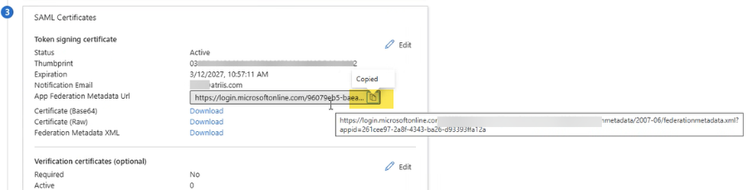
- Reply URL (ACS):
https://www.gtp-marketplace.com/identity/<UNIQUE_ID>

- Sign-on URL:
https://www.gtp-marketplace.com/sso/newidp?provider=<UNIQUE_ID>&clientId=atriis_ui_production_sso&redirectUri=https://www.atriis.app/signin

4. Testing the Integration
Once Atriis confirms setup is complete:

Option 1: Azure Test Tool
Use the “Test this application” option in Azure
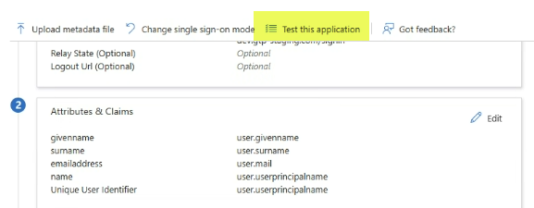

Option 2: Direct Login
- Open the Sign-on URL in Incognito mode

Important
- Ensure the test user exists in Atriis

5. Optional: Advanced SSO Parameters
Atriis supports additional SAML attributes to enhance the login experience.
These can be configured by your IT team.

Traveler Username
Defines the travelers included in the trip:
["traveler@company.com"]
- If the user does not exist in Atriis, they will be treated as a guest traveler

Client Reference Fields
Used to pre-fill client-specific fields:
{
"ClientRefFields": [
{"UID": "RM1", "Value": "Project A"},
{"UID": "RM2", "Value": "Cost Center 123"}
]
}
- UID = predefined field identifier
- Value = field value

Search Parameters (Optional)
Predefines trip details during login:
{
"TripType": 1,
"Segments": [
{
"Origin": "LHR",
"Destination": "PAR",
"DepartDateAt": "2025-08-28T00:00:00",
"Cabin": "Y"
}
]
}

Key Fields
- TripType
  - 0 = One-way
  - 1 = Round-trip
  - 2 = Multi-city
- Segments
  - Origin & Destination = IATA airport codes
  - DepartDateAt = ISO format (YYYY-MM-DDTHH:MM:SS)
- Cabin
  - Y = Economy
  - W = Premium Economy
  - C = Business
  - F = First

